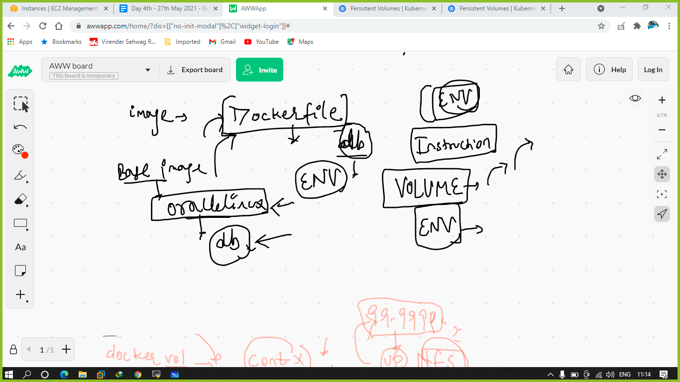

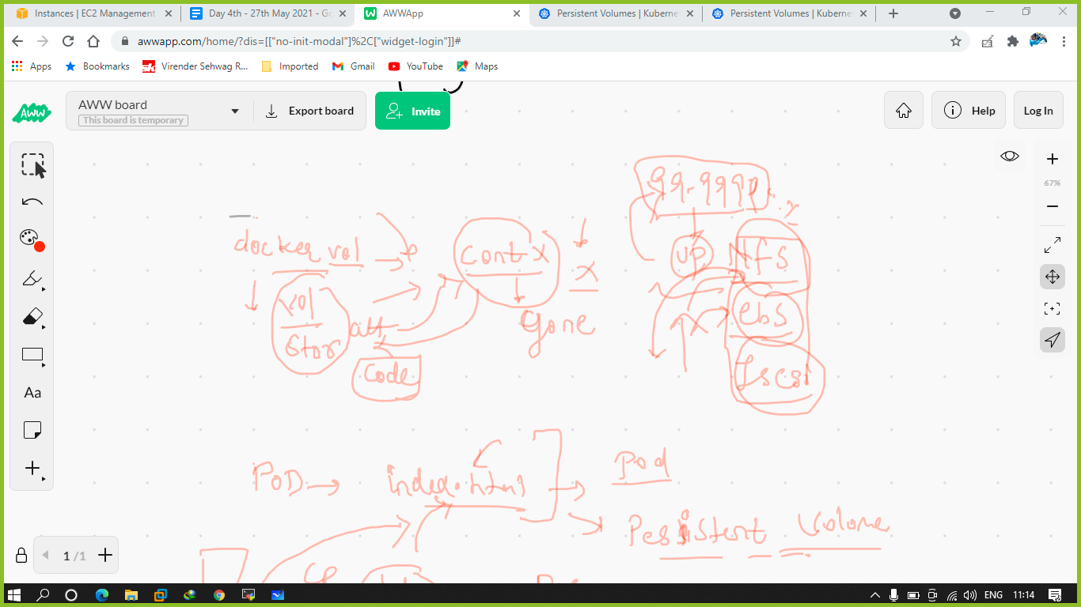

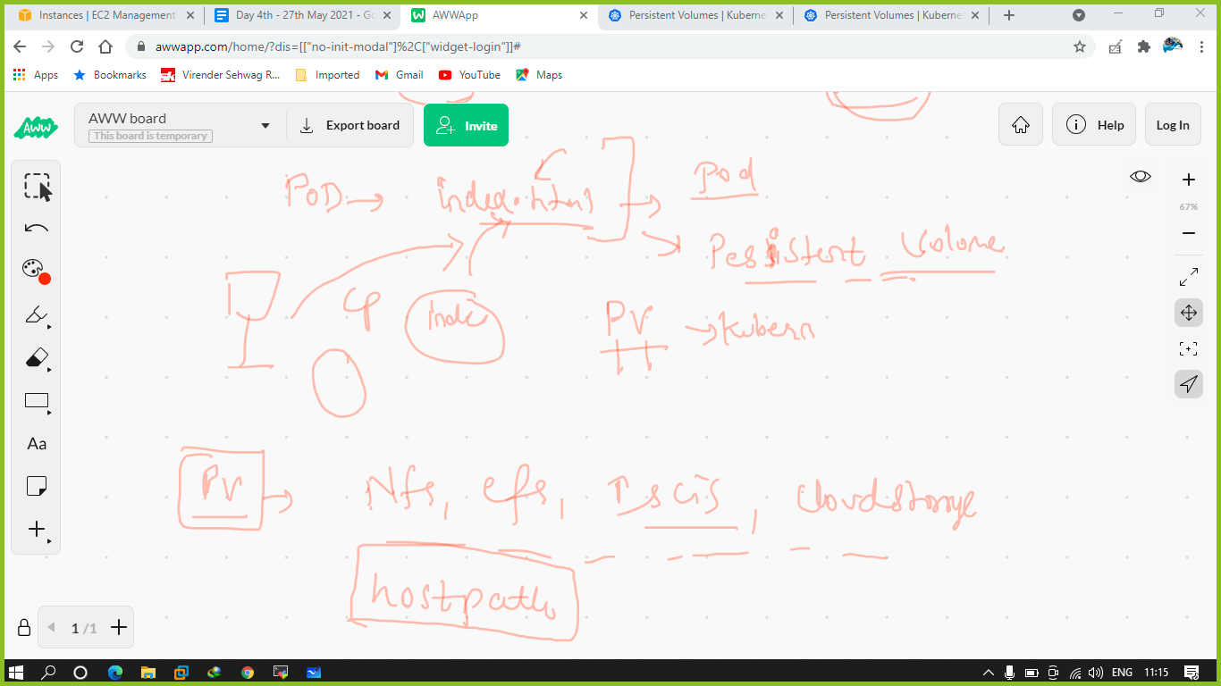

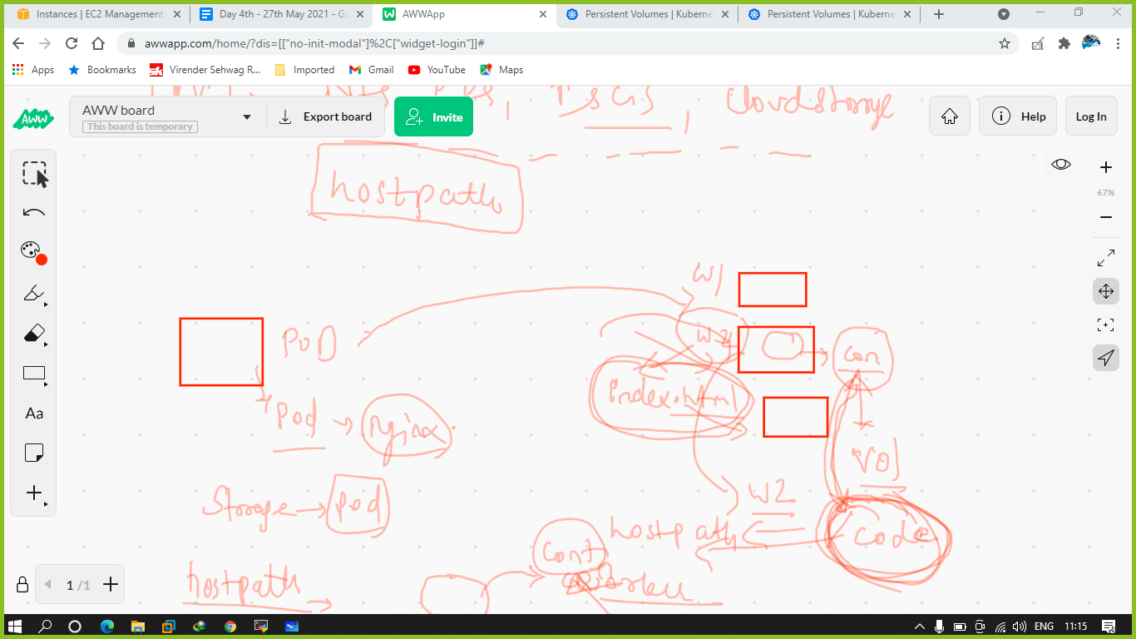

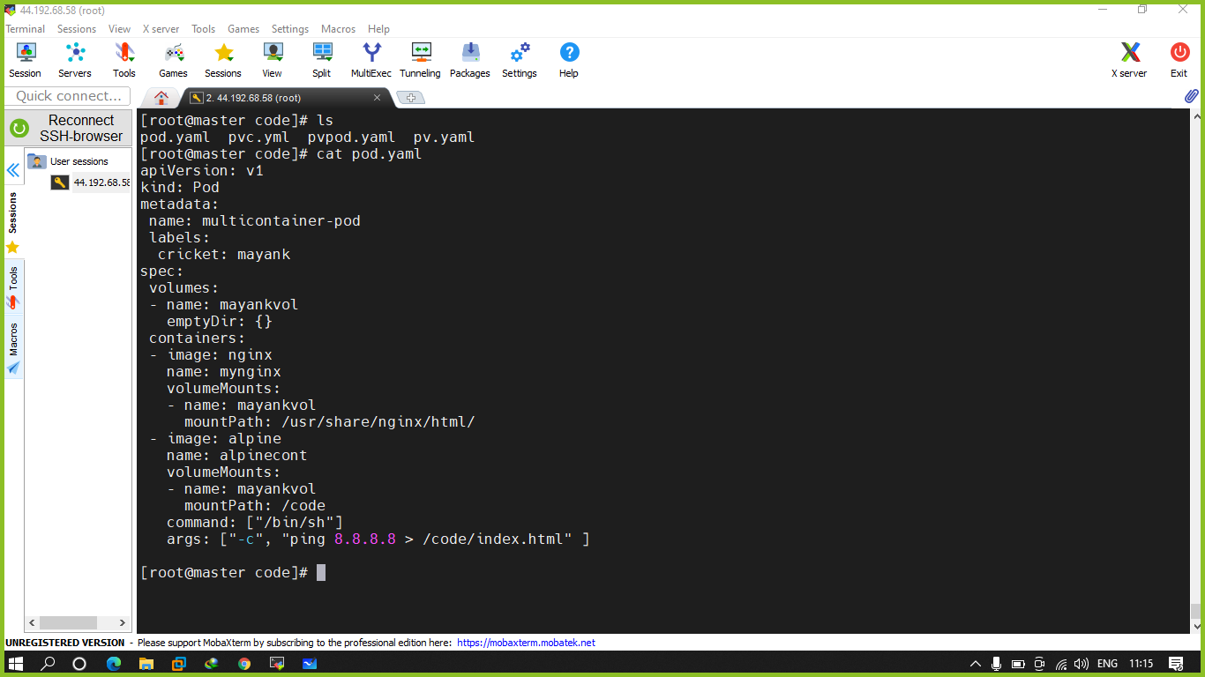

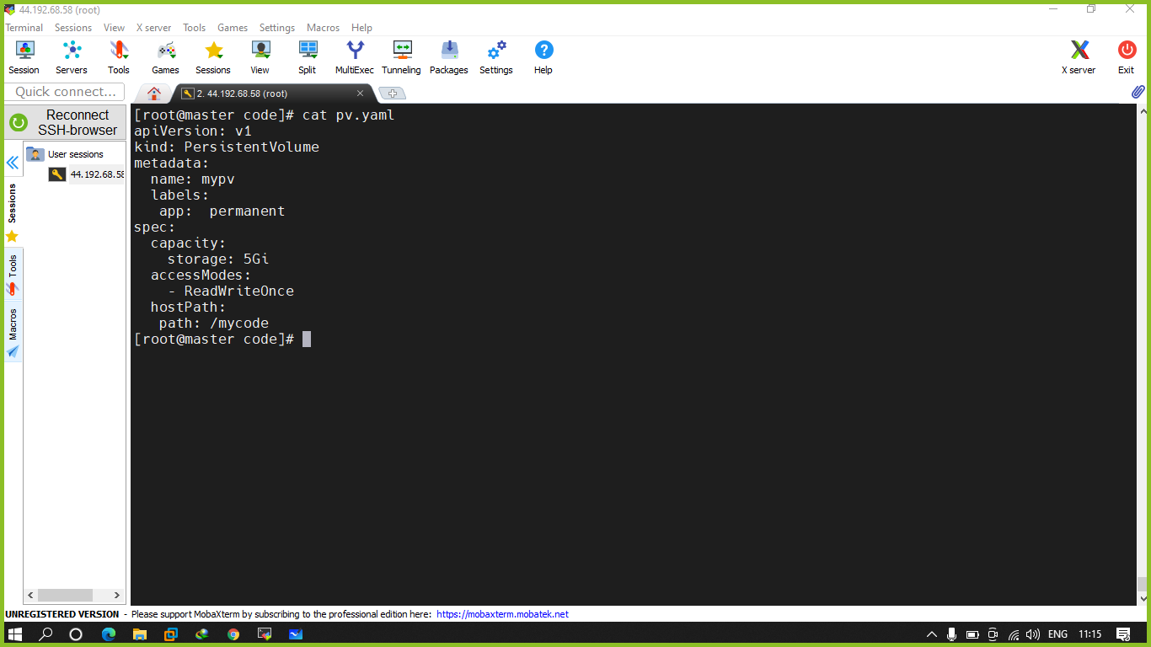

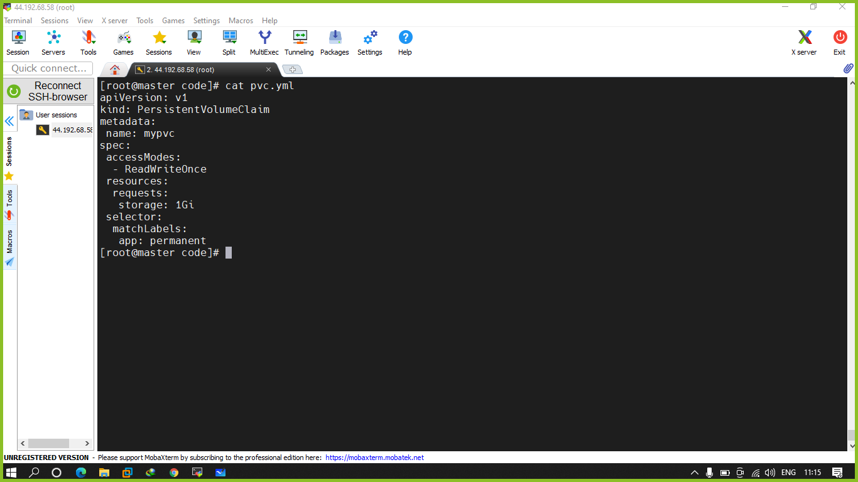

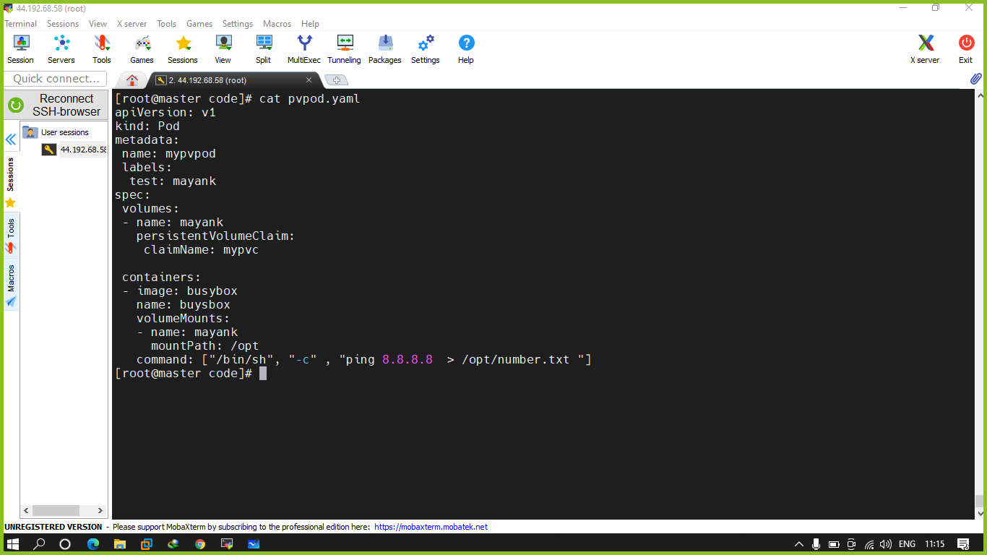

**apiVersion: v1**

**kind: Pod**

**metadata:**

**name: multicontainer-pod**

**labels:**

**cricket: mayank**

**spec:**

**volumes:**

**- name: mayankvol**

**emptyDir: {}**

**containers:**

**- image: nginx**

**name: mynginx**

**volumeMounts:**

**- name: mayankvol**

**mountPath: /usr/share/nginx/html/**

**- image: alpine**

**name: alpinecont**

**volumeMounts:**

**- name: mayankvol**

**mountPath: /code**

**command: ["/bin/sh"]**

**args: ["-c", "ping 8.8.8.8 > /code/index.html" ]**

**apiVersion: v1**

**kind: PersistentVolume**

**metadata:**

**name: mypv**

**labels:**

**app: permanent**

**spec:**

**capacity:**

**storage: 5Gi**

**accessModes:**

**- ReadWriteOnce**

**hostPath:**

**path: /mycode**

**apiVersion: v1**

**kind: PersistentVolumeClaim**

**metadata:**

**name: mypvc**

**spec:**

**accessModes:**

**- ReadWriteOnce**

**resources:**

**requests:**

**storage: 1Gi**

**selector:**

**matchLabels:**

**app: permanent**

**apiVersion: v1**

**kind: Pod**

**metadata:**

**name: mypvpod**

**labels:**

**test: mayank**

**spec:**

**volumes:**

**- name: mayank**

**persistentVolumeClaim:**

**claimName: mypvc**

**containers:**

**- image: busybox**

**name: buysbox**

**volumeMounts:**

**- name: mayank**

**mountPath: /opt**

**command: ["/bin/sh", "-c" , "ping 8.8.8.8 > /opt/number.txt "]**

**Q.1 first use emptydir and store the data into container and mount that same volume into diff container to verify .**

**Q.2 create a persistentstorage**

**Schedule your pod on node3 --- hostpath .. node3**

**/**

**ConfigMap:**

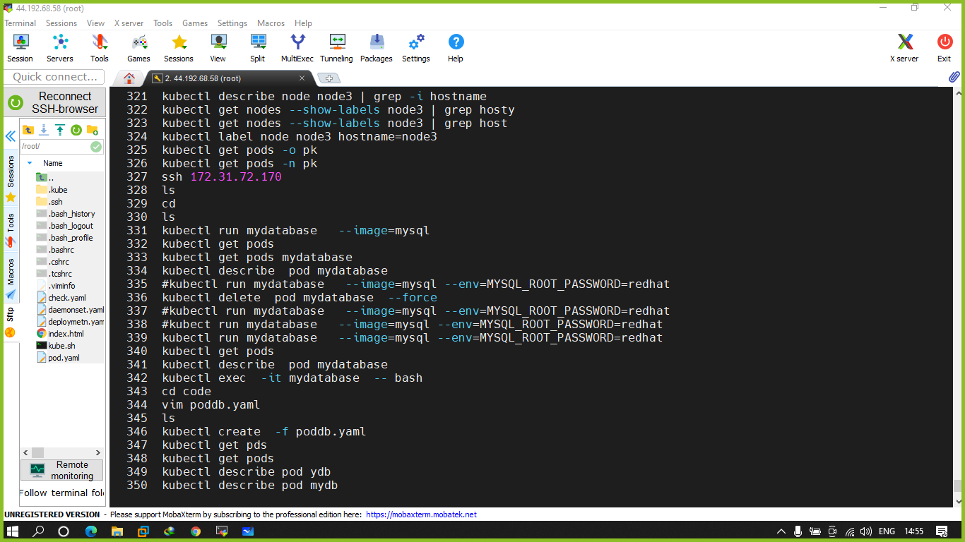

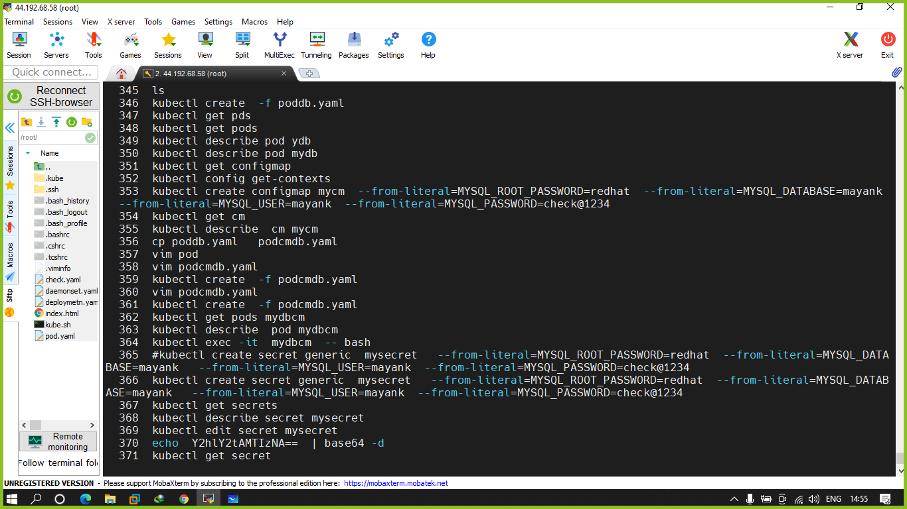

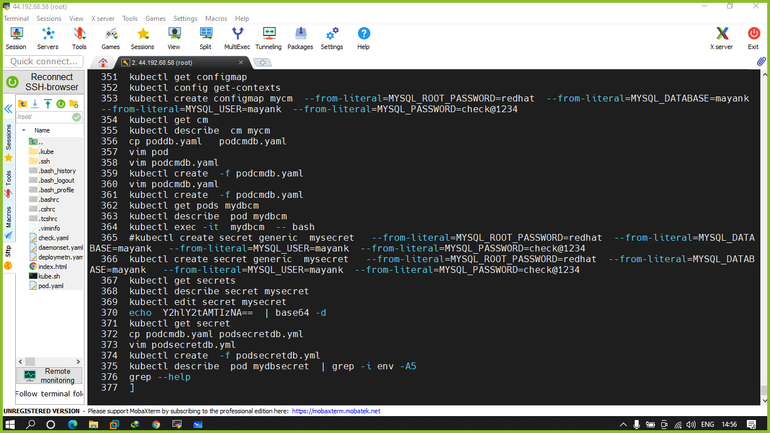

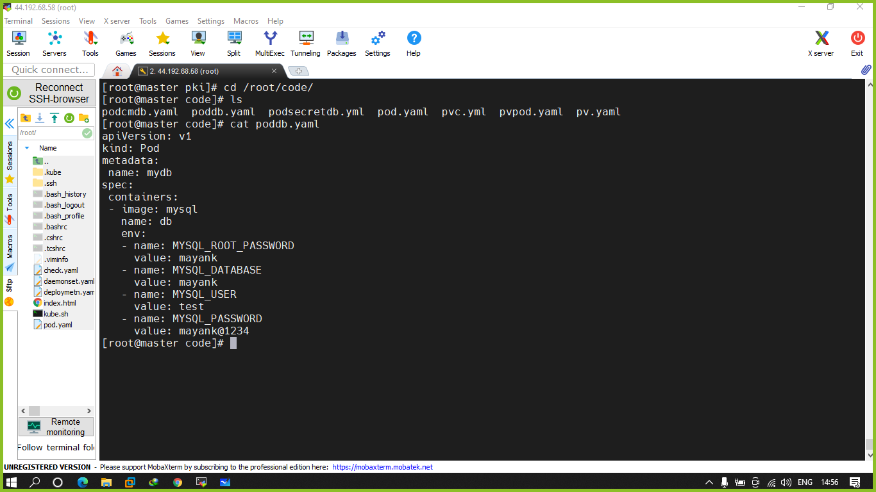

**apiVersion: v1**

**kind: Pod**

**metadata:**

**name: mydb**

**spec:**

**containers:**

**- image: mysql**

**name: db**

**env:**

**- name: MYSQL_ROOT_PASSWORD**

**value: mayank**

**- name: MYSQL_DATABASE**

**value: mayank**

**- name: MYSQL_USER**

**value: test**

**- name: MYSQL_PASSWORD**

**value: mayank@1234**

**apiVersion: v1**

**kind: Pod**

**metadata:**

**name: mydbcm**

**spec:**

**containers:**

**- image: mysql**

**name: db**

**envFrom:**

**- configMapRef:**

**name: mycm**

**apiVersion: v1**

**kind: Pod**

**metadata:**

**name: mydbsecret**

**spec:**

**containers:**

**- image: mysql**

**name: db**

**envFrom:**

**- secretRef:**

**name: mysecret**

[**https://www.hashicorp.com/blog/injecting-vault-secrets-into-kubernetes-pods-via-a-sidecar**](https://www.hashicorp.com/blog/injecting-vault-secrets-into-kubernetes-pods-via-a-sidecar)

[**https://learn.hashicorp.com/tutorials/vault/kubernetes-external-vault**](https://learn.hashicorp.com/tutorials/vault/kubernetes-external-vault)

**Q.1 create a pod that wil use and config ..-- mysql**

**Q.2 MYSQL -- env -- in a yaml**

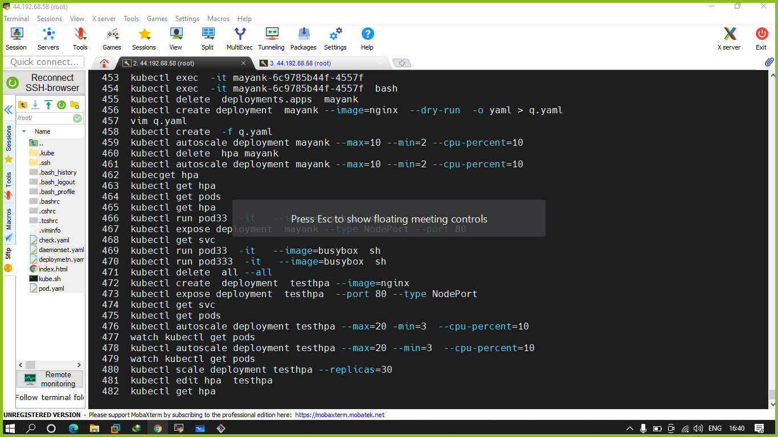

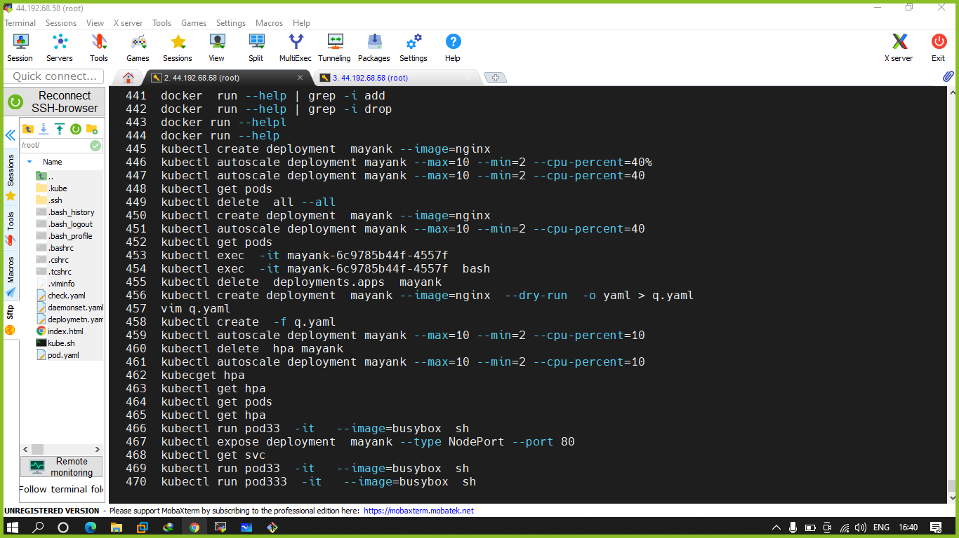

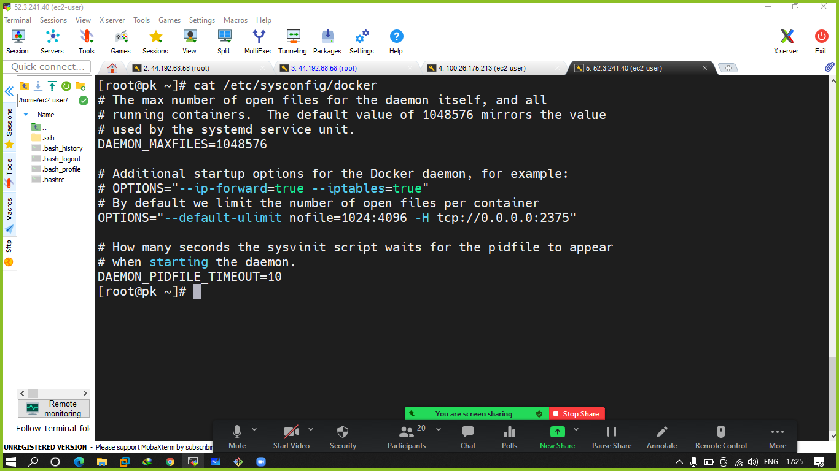

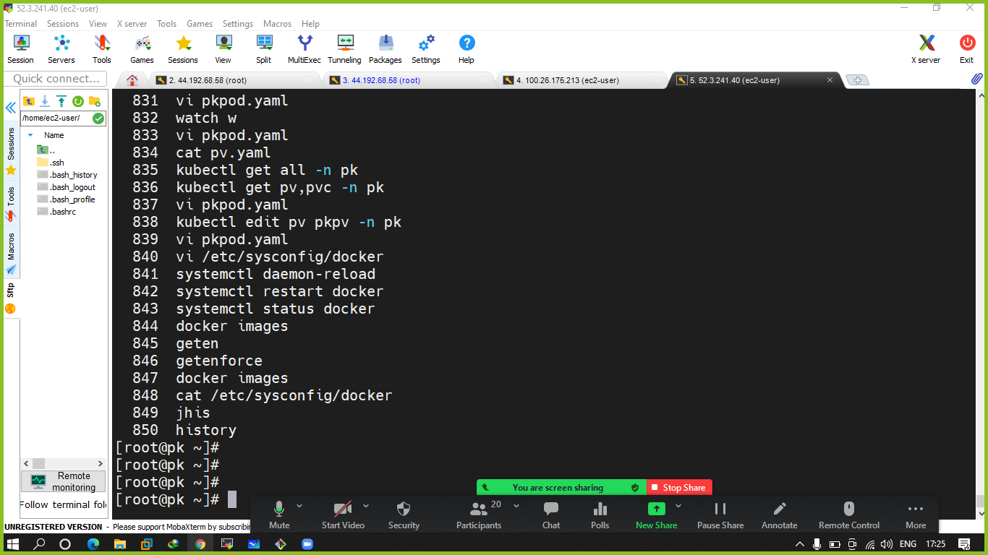

**Server side**

**export DOCKER_HOST=tcp://52.3.241.40:2375**